**Self-Report**

**Week 1 - 2**

In this this team project my role was to initially find an idea that me and my teammate agreed upon.

I decided to go for an old school project that was never picked up by my class.

It was a thermometer that would sense the temperature outside and based on the result it would give feedback to the user, advising them whether they should go outside or not.

The first week or so I spent learning how the Arduino works. I did this at home on the emulator online to try and get the most basic code to make sense to me. Thankfully it wasn’t long before we got our hands on a physical Arduino device along with the Starter Grove Kit.

We also decided our roles in this project, it was decided that Shane will do most of the writing aspect and will handle the Trello work, while I will be the one coding on the Arduino.

**Week 3 – 5**

Before attempting the actual project code, I wanted to test if I was able to program the Arduino correctly and if I was able to upload it properly.

All of this was being tracked in the team report and on our Trello page.

Here are some pictures of the Arduino Testing:

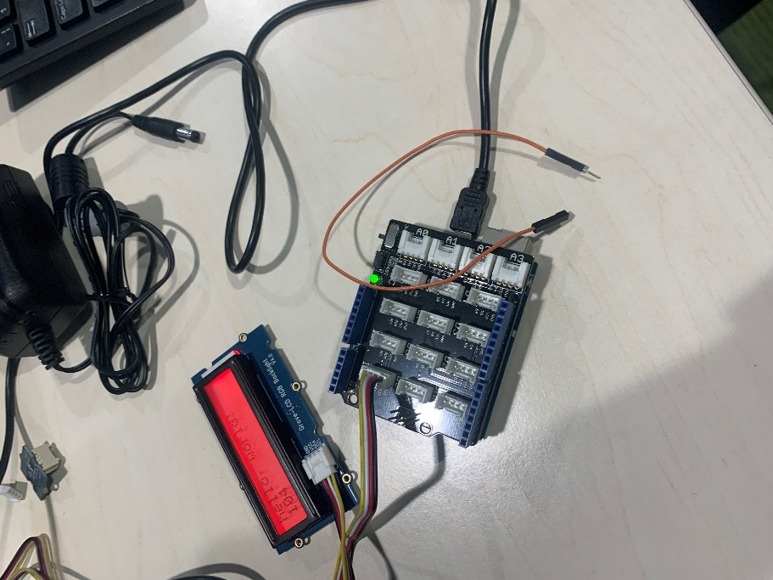 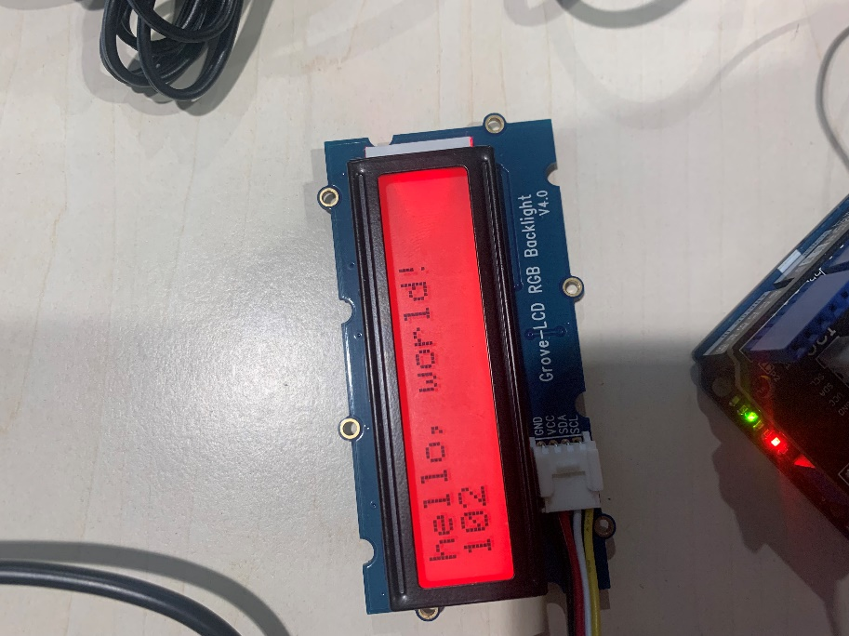

Once we got used to the Arduino and how it works we decided that I should handle the coding aspect. After researching on how to plug the Arduino in correctly I began to attempt the code. After my first attempt of making a thermometer was successful. The code looked like this:

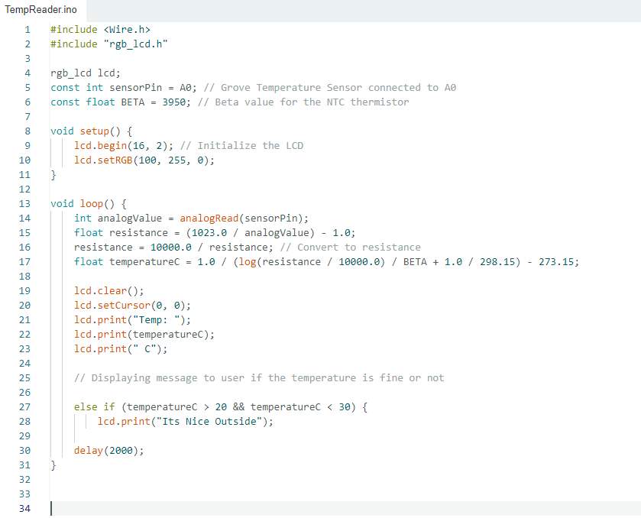

And the physical device looked like this:

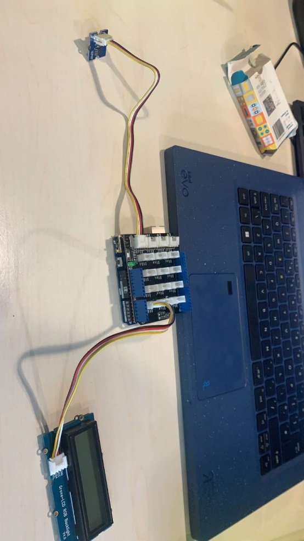

**Final weeks of coding**

After the project was working, I decided that our basic weather thermo sensor was a bit too basic, hence I decided to add more statements to different temperatures outside, and while doing so I also made the RGB screen different colors to suit the different kind of weather it was detecting. E.g. Red = Hot, Blue = Cold etc.

Picture of the Final Code:

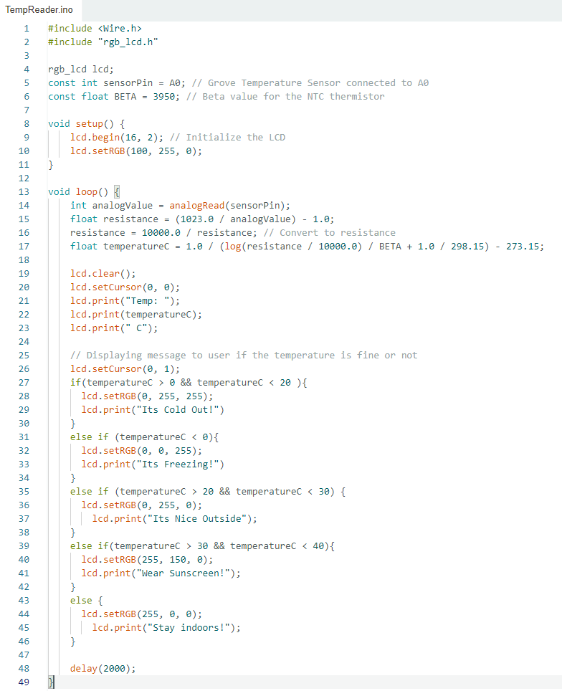

In the end I was very please with how it turned out and my teammate was too!